
Online edition of India's National Newspaper
Friday, Aug 20, 2010
http://www.thehindu.com/thehindu/fr/2010/08/20/stories/2010082051380400.htm

Back Friday Review Bangalore Chennai and Tamil Nadu Delhi Hyderabad Thiruvananthapuram
Symmetry in singing
LALITHAA KRISHNAN
Maharajapuram Ganesh Viswanath ably juxtaposed karvais and rapid prayogas.
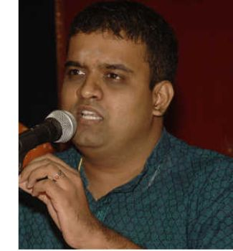
Maharajapuram Ganesh Viswanath.
Lalitha Kala Vedika celebrated its 15th anniversary with a two-day music and dance fest. Vocalist Trichur V. Ramachandran and jalatharangam artist Anayampatti S. Ganesan were presented with awards by Nawab Mohammad Abdul Ali, Prince of Arcot, and felicitated by vidwan T.R. Subramaniam and Ramabhadran (founder, Shanthi Arts) on the first day.
In right earnest
A concert by Maharajapuram Ganesh Viswanath followed. After a line-up of compositions that included ‘Vighna Raja' (Suddha Dhanyasi) and ‘Gowri Sukumari' (Vasantha), Ganesh stepped into manodharma territory with his elaboration of two ragas, Shanmukhapriya and Harikhambodi, displaying an earnestness that shone through his delineations.
The Shanmukhapriya alapana moved at a relaxed pace, employing vadi samvadi phrasing and the principle of contrast through aptly juxtaposed karvais and rapid prayogas.
Papanasam Sivan's ‘Aandavane Unnai Nambinen' was rendered with due respect for sahitya bhava. Sarvalaghu swaras with panchama-varja phrasing offered a change from the beaten track, with the artist keeping the final korvai simple and effective.
The Harikhambodi exposition had raga-affirming madhyamakala passages that ambled through familiar lanes to their rendezvous at the dhaivata. The Tyagaraja kriti ‘Undethi Raamudu' and niraval at ‘Taamasaadhi' dwelt on niceties with a relaxed air. Kalpanaswaras leading to the kuraippu at the dhaivata were highlighted by symmetrical permutations.
The artist's facile voice that traversed the octaves smoothly, and the open-throated handling of the upper octave, maintaining evenness of tone sans constriction, was appreciable. When the vocalist was in full flow, it would have been to his advantage to allow for strategic pauses between raga sancharas, in the nature of a breather, enabling the violin to follow through.
Sahitya enunciation, which tended to emerge in a drawl, would have benefited from greater clarity. M. Rajeev's violin support and responses complemented the vocalist's efforts. An experienced hand, Thanjavur Kumar led the rhythmic suite on the mridangam, closely shadowed by D.V. Venkatasubramaniam on the ghatam.
© Copyright 2000 - 2009 The Hindu

